VERIFICATION OF RECCOMENDAITONS
FROM THE 2ND EU4BE ANALYTICAL BUSINESS ENVIRONMENT REPORT:

WORLD CAFEE PUBLIC-PRIVATE DIALOGUE
( SEP 2022 – FEB 2023)
AND
VALIDATION WORKSHOPS REPORT
BY
Center for European Policy (CEP)
February 2023

- SUMMARY
The 2nd EU4BE Business Environment (BE) Analytical Report, prepared in July 2022, provides 25 recommendations for further improvement of business environment in Serbia, as well as the results of measurement of administrative costs of the businesses according to the Standard costs model (SCM) to determine the most burdensome procedures and costs for the economy. Even though these recommendations and the list of the costliest procedures were developed based on comprehensive research of available primary and secondary sources and in-depth analytical work, in order to verify these findings with the businesses, and to identify priority interventions to improve the business environment, workshops with businesses and their associations and business support organisations were organised and delivered in the period December 2022 – February 2023.
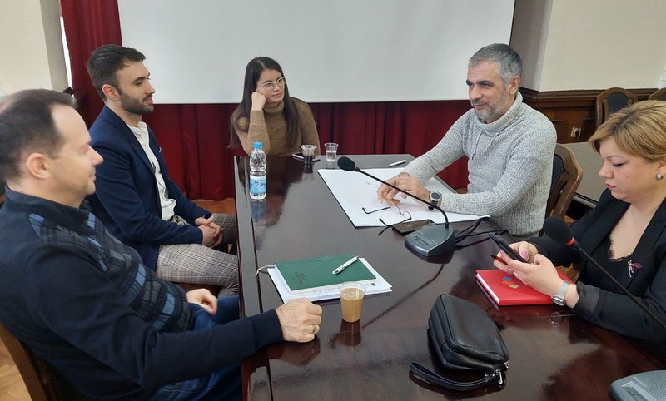
Workshops were organised in the form of World Café (see the next section) in Niš (01/12/2022), Kraljevo (13/12/2022), Čačak (15/12/2022), Valjevo (31/01/2023) and Novi Sad (09/02/2023) and in cooperation with the Serbian Chamber of Commerce and Industry (SCCI) and regional chambers (RC).
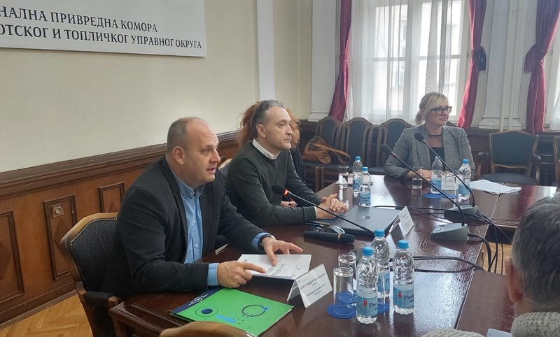
In total 86 participants contributed the workshops. Out of this number, 32 representatives of the companies were present, 16 came from the RCs and local or regional entrepreneurs’ associations, 8 from local self-governments, 16 representatives of business support associations (such as scientific-technological parks, regional development agencies (RDAs), clusters), 6 civil society organisations (CSOs) dealing with economic development and entrepreneurship. Also, beside representatives of World bank’s EU4BE project (3), EU Delegation to Serbia (1), beneficiaries’ institutions (2), additional two representatives of state institutions were present (National Employment Service in Niš and Kraljevo). The strongest participation of businesses was in Čačak and Valjevo, while the workshop in Kraljevo marked the lowest turnover of entrepreneurs. They operate in different sectors, depending on the region – in Niš companies dealing with IT and from hospitality sectors dominated; in Čačak representatives of strong, medium-sized firms in transport and food-processing sector were majority, while in Valjevo enterprises dealing with plastic products, and all suppliers of big international companies from the region, were present.
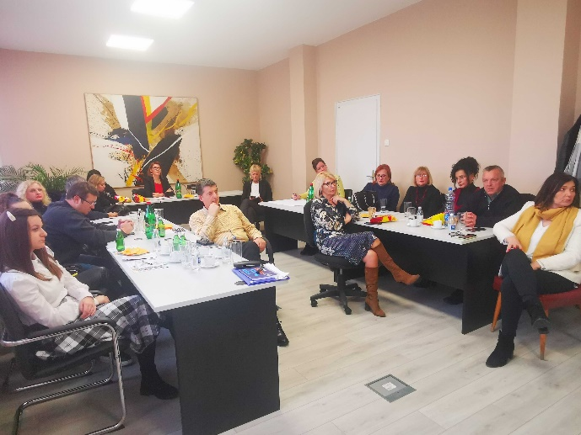
As mentioned above, all five workshops were organised in cooperation with RCs, in their premises. Experts engaged to perform these validation workshops prepared the material (invitation letters, agendas, document on the concept of World Café to acquaint participants in advance on what is expected from them), while the RCs sent invitations to the companies in their data bases, together with the 2nd EU4BE analytical report and its recommendations. Despite the good will of the RCs to support organisation, the initially planned period for these events (beginning of the 4th quarter of 2022) proved to be quite challenging due to different events and foreign visits that took part in October and November. Additionally, New Year’s and Christmas holidays, which in Serbia, especially outside of Belgrade, can last until the end of January, further delayed finalisation of the workshops (until February 2023) as RCs assessed that the turnout wouldn’t be adequate. Another difference is also noted between regions and RCs – those RCs which are swamped with different events for their companies, visits of foreign state and business delegations and also are in the centre of attention of FDIs, struggle to attract their entrepreneurs and make them interested for new events. Also, if the companies don’t see the results coming out of their contributions, they are likely to give up participation in future events. At the end, a lot also depends on the people – employees in the RCs. Where the staff is proactive, maintains good relations with the companies and can explain why it is important to participate - attendance is higher and companies are more willing to contribute and provide their opinion, experience and inputs.
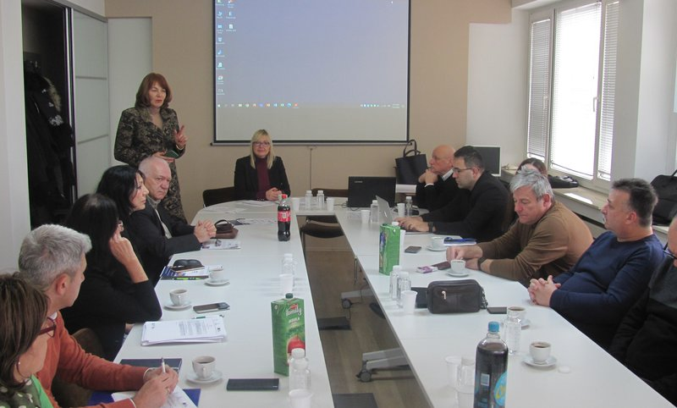
RCs also proposed some additional workshops to be held for example in Loznica. It is their opinion that the companies in those cities are quite active and would contribute and gladely share their experience.
The results of the workshops proved to be interested and important. Not only that the participants provided insight into the recommendations of the 2nd Eu4BE analytical report, but they also listed additional issues they face within their everyday operations. It is substantial to stress that the common obstacles and issues that burden their businesses have crystallized already after the first events and were further confirmed during the later workshops. In section 3 of this report, we list all findings from the workshops as well as recommendations, but here we would like to stress some of the most important issues:
- Improvement of business environment in Serbia is evident. Yet, participants believe it is still complex and complicated;
- E-Government introduced in recent years has significantly impacted everyday operations of the businesses and has made access to public authorities and the services they provide, easier;
- All participants agree that despite the effort which the Government invests in simplifying procedures and increasing the range of e-Government services, not all institutions are yet connected to e-Government, especially the local authorities which provide some key public services to businesses;
- Not many participants have heard about the Register of Administrative Procedures (RAP) before the events, but all of them acknowledge the progress that the Serbian Government has made in terms of simplification of administrative procedures and cutting the costs for doing business;
- Newly introduced legislation (E-fiscalization, E-invoices and archiving) imposed additional obstacles to everyday operations of business operators in Serbia, especially to micro and small enterprises which do not possess resources (human, financial) to adequately comply with new requests;
- Inspections should focus on education and have a preventive role, especially when it comes to obligations imposed by the newly introduced legislation;
- Validity and importance of the majority examined findings and recommendations of 2nd EU4BE analytical Report was confirmed. Only for one recommendation (recommendation no. 23, related to payment of taxes and contributions) all participants agreed that it should not be implemented, especially taking into account past events in Serbia, during the 1990s’ and early 2000s’.
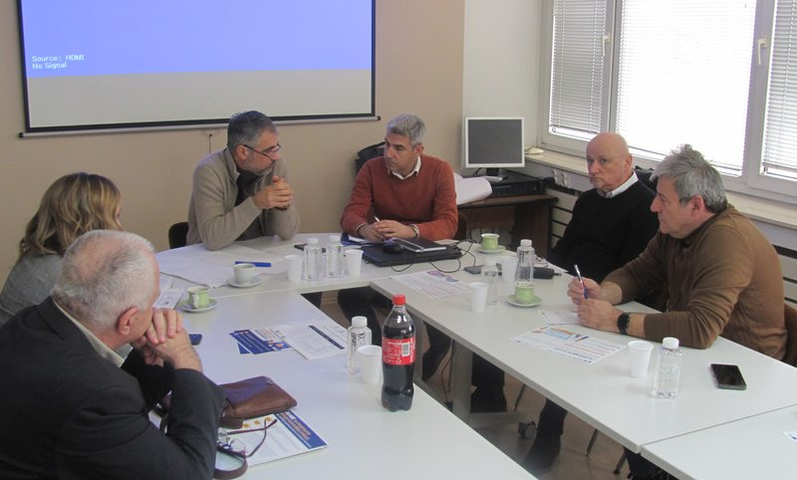
Specific recommendations to address each issue are provided in the table below (Section 3). Transformation of public institutions towards customer oriented and business friendly service providers able to deliver high-quality, quick and efficient services should continue. In addition, raising awareness of the public servants on their responsibility and accountability towards taxpayers and users of their services is required as well as stronger promotion of tools that facilitate everyday operations of the companies (such as the RAP).
- METHODOLOGY
Validation workshops were organised and delivered in form of the World Café. World Café is a simple, yet advanced method for organization of discussion and dialogue on important issues in groups, and it is conducted in a relaxed, dynamic and informal atmosphere. It is a tool which stimulates interaction of all participants and fosters their engagement. Each World Café is adapted to the topic and the desired aim which places strong emphasis on the preparation of the event.
What differs the World Café from classical forms of events is their less formal character, where the participants do not speak directly to representatives of the public sector and in front of all other attendees (which may lead to insecure and nervous speech). On the contrary, the World Café enables participants to provide comments, suggestions, inputs or contributions in a relaxed atmosphere and “chat” with other participants. Everybody actively participates at the event and is involved in discussion under every topic. This setting leads to less pressure and participants are more willing to contribute. Equal participation is also facilitated by the moderator.
Although every World Café is adapted to the context, they all have the following five components:
- Setting – Specific environment is created i.e. café atmosphere, with the tables for 5-6 chairs, and equipped with flipchart papers, notebooks, sticky notes, markers etc.
- Welcome note and introduction – host of the event greets the participants, provides the introduction and acquaints them with the form and context of discussion as well as the rules.
- Smaller groups discussions – discussions are organised around tables in 3-5 rounds (depending on the number of tables, which again depend on the number of areas where the contribution is asked for) lasting from 20 to 30 minutes. After each round is finished, participants move to the different table and topic they still haven’t discussed, so that they all have the opportunity to discuss and provide their contributions for each topic. Each table has a moderator (host), who facilitates the discussion, take notes and marks key comments on a flipchart, as well as briefly informs each group on discussions in the previous rounds.
- Questions – the aim of discussions in each table is defined with the question at the beginning of the round. Questions can remain the same for each round or can be upgraded or complemented during discussion.
- Summary/”harvest” – content and results of discussions are presented to all participants, using different methods (flipcharts, visual presentation, etc.).
When it comes to the World café events organized to validate the findings of 2nd EU4BE analytical report, discussions were organized in three rounds around three topics. At least 4-5 participants were gathered around each table at the events, while the rounds lasted 30 minutes. After finalization of all three rounds, the results were presented to all participants to ensure the most relevant conclusions were made and issues highlighted. On several occasions, the audience intervened and added additional points to the conclusions.
As mentioned in the previous paragraph, workshops covered three topics of importance for the business environment in Serbia:
- E-Government, administrative simplification and reduction of administrative costs;
- Starting and closing the business including insolvency issues;
- Doing business in other specific areas.
The first topic included issues related to administrative procedures, RAP, e-Government services, the most important costs incurred in complying with the administrative procedures etc.
Under the second topic, discussion was organized around the questions related to the procedures for starting the business, for new staff employment, communication with the Serbian Business Registry Agency (SBRA) and Central Registry of Compulsory Social Insurance (CROSO), as well as cooperation with the Tax Authority, VAT return, lump sum taxation, accounting costs, archiving and finally, closing of business.
The third topic was related to obtaining building permits, electricity, registration of property in cadaster, access to finance, protection of minority rights, introduction of the unified system for collection of taxes and contributions for employees, collection of receivables based on enforcement of court judgments, etc.
The main questions for each topic were prepared in advance by the EU4BE team and approved by the Public Policy Secretariat (PPS) and are annexed to this Report (Annex 1). Discussions were, however, often steered based on additional sub-questions based on the issues raised during each round.
Main results of discussions are summarised in the table below, together with recommendations for further actions.

- FINDINGS AND RECOMMENDATIONS

Findings in this report are based on the recommendations from the 2nd EU4BE Busines environment Report, but are organized according to the prioritzy areas as defined in the Draft Small and Medium Enterprises Strategy of the Republic of Serbia for the period 2023-2027.

A. | Table 1: I. E-Government, administrative simplification and reduction of administrative costs
No | Sector | Specific area | Findings | Recommendations
1. | -E-Government | Digital public services | E-Government has significantly simplified everyday operations for businesses and everybody welcomes progress in this area. A lot has been accomplished in the recent years – procedures are faster, simplified and significant savings in time and money are achieved. The only remark relates to connection of all institutions, especially the local administration and all their services with the E-Government portal, as not all institutions and local services even within the same local self-government are connected.  Good example – TEHNIS portal of the Ministry of Economy, where all information on products certification for export and safe placement on the market can be obtained.  Some negative examples are the procedure of vehicle registration – which is still a paper procedure. Also, the Ministry of Agriculture, when it comes to national measures for support to agriculture - all procedures are in paper.  Recommendations of 2nd EU4BE analytical Report on e-Government and improvement of electronic public services (1, 2, 3, 4, 6) were confirmed and welcomed. | To continue with further digitization of public services and to work stronger on connecting all institutions and all services, especially at the local level to the e-Government portal. Additional effort should be invested to introduce e-Government services in all public institutions, not only at the national or provincial level, but also at the local level as the local self-governments provide some of the most frequent and important services to businesses. Further improvements should also be made in the direction of providing the status of electronic procedures, as businesses think that there is no sufficient information on this status.
2. | Administrative procedures | Registry of public procedures (RAP) | Businesses in Serbia are not familiar with RAP and do not use it in their everyday operations even though they acknowledge the progress that the Serbian Government has made in terms of simplification of administrative procedures and cutting the costs, especially at the national level. Local administrative procedures still represent a significant burden for the businesses. They are not aware on how they can use the RAP and how it can simplify their operation. | RAP should be more promoted; it is not visible at the E-Government Portal, as the banner is posted only at the bottom of the page, while other institutions and public organizations do not provide links on their websites to RAP. Cooperation can be established with the Development Agency of Serbia, accredited regional development agencies and the SCCI to promote RAP using their portals as well. Banner from the portal “Preduzetništvo” should also lead to RAP, while the benefits of social media can also be used to promote this useful tool. Stronger exploitation of traditional media should also be examined.
3. | Administrative procedures | Ex officio acting of public institutions | For various administrative procedures and requests, majority of businesses are still advised to provide documents and data already contained in the public registries, as this will “make the procedure more efficient and faster” then in case when the data are obtained ex officio; | Provide capacity building for the civil servants working on different public services and administrative procedures in order to ensure they fully understand their obligations and provisions of the Law on General Administrative Procedures (LGAP). In addition, awareness of the citizens and businesses on their rights from LGAP and ex officio obtaining of documents from public registries should be raised. Posters or flyers should be distributed in the local self-governments and public institutions.
4. | Administrative procedures | Cooperation of different institutions in one administrative procedure | In administrative procedures, one of the issues businesses face with, is cooperation between several institutions and exchange of data among these institutions. Example is the change of status of entrepreneurs, as there is no link between SBRA, Tax Authority and CROSO. Thus, optimisation and digitization of procedures works if one institution is involved in one procedure. If aprocedure involves more institutions, the challenges in their cooperation and the lack of inter-linkages are visible. | To put additional efforts in fostering collaboration of different institutions involved in administrative procedures and their electronic links. This should also include trainings and education of civil servants in these institutions working on concrete administrative procedures.
5. | E-Government | Cooperation with SBRA, Tax Authority, CROSO and other institutions | SBRA has always been highlighted as a good practice example. The only issue is related to the fact that taxes still cannot be paid electronically, while acquiring the documentation required for compiling applications for public procurement is still in paper. As a good example, the advisory role of SBRA has been emphasised.  Tax Authority also improved its procedures with the introduction of its specific applications. All procedures for legal entities and entrepreneurs are preformed through this application. However, businesses would still like to have “a human” to talk to and ask for the advice. Good example is the window of Tax Authority in the Shopping mall, where all interested persons, both natural and legal entities can ask for advice. Similar services, at public places, can be introduced in other local self-governments.  Cooperation with CROSO is also satisfying. There is a recommendation for CROSO to allow businesses/potential employers to cross check the employment history of the potential employee (not to enable data on previous salaries, but also information on their previous engagement).  Bad practice examples are EPS and local utility companies which still have not implemented digitization of their services and procedures. | Even though businesses acknowledge the progress in work of public institutions, this work still has not been finalised. Recommendation is to continue improvement of the work of key institutions dealing with businesses and to further advance their services for businesses.
6. | Archive | E-archiving, keeping of records and archive books | Businesses believe that the e-Archive has not completely fulfilled its purpose and provided cutting the costs and simplification of procedures. Namely, additional requirements for filing and keeping paper documentation have additionally burdened the business process in terms of time and resources (human and financial). Also, the manners for keeping the records, deadlines and other procedures have not been synchronised and can be interpreted in different manners. Sanctions are also interpreted differently and can differ from one regulation to another so SMEs are not sure when they make a mistake and when they act properly. In addition, fines are too high compared to the size of a business.  As an illustrative example, the obligation to keep records for all public procurements is provided. One company can bid in over 200 public procurement procedures or public calls. Out of these 200 bids, they will be successful in 4-5 or even less, but they are obliged to keep all records, even for those unsuccessful ones, for 10 years. | The transformation to fully digital ways of doing business is not possible, until archiving is also performed as e-archiving. For now, it is still in the paper form and compliance to the new regulation has made an additional burden to the businesses, requiring more time and costs. All relevant legislation that regulates this area should be harmonised, such as the Law on Accounting, Law on archive documentation, etc, where the Law on Accounting should become an umbrella systemic law.  Fine policy and regulations in different legislation should be harmonised, based on the umbrella law, and prescribe and harmonise sanctions and fines adapted to the size of company and their operations.
7. | E-Government | E-invoicing, E-fiscalization | E-invoicing and e-fiscalization are currently the most burdensome legislations for the businesses in Serbia. E-fiscalization creates issues only when it comes to availability of good internet connection. Issues in e-Invoicing are more complex and more frequent. Impressions of the companies are that not only they have not been sufficiently prepared for this, but also that the government and public institutions lacked proper preparation. Some improvements after the first period have been noted; administators do take into account users feedback and comments. However, everybody is still adapting to the new solutions.  Additional issue businesses are concerned about is data protection. All data on daily turnover, suppliers, prices, etc., are available at the Tax authority server and businesses wonder if there would be adequate data protection or these data can be easily accessed by third parties. | System support for the new solutions should be improved and strengthened. New systematic laws require longer periods of adaptation and transformation, so the Government should envisage more support in this initial period and should act more educative and preventive, rather then to impose sanctions. Comprehensive trainings in all parts of Serbia should be organised and repeated, while manuals and instructions should be provided and written in a simple and clear, easy to understand langugage, and not in a birocratic manner.  More attention should be paid to data protection and data security, and to improve this aspect constantly.
8. | E-government | Bookkeeping | Bookkeeping definitely accounts for the highest costs, but all entrepreneurs agreed that the services which accountants provide are of utmost importance and worth the costs. Accountants provided all legal information, counselling and advice to businesses. It is highly likely that this role will become even more important with entry into force of new laws adopted in the past period (e-Invoicing for example). There is some information that the costs for accountants will increase in the upcoming period, as they may start to charge e-invoicing and uploading at the system (150 rsd per invoice).  Entrepreneurs in some sectors (IT) prefer to perform electronic procedures by themselves. They believe that these procedures are quite simple and sometimes they understand processes and procedures, electronic ones, better then accountants. | More education and trainings should be provided to accountants in order to enable them to fully understand and are able to support businesses in complying with all requirements and procedures imposed by the regulations.  In addition, awareness of the entrepreneurs on the ease of performing some digitized procedures should be raised along with boosting their interest to acquire an electronic signature.
9. | E-government | Local self-governments | Internet presentations and websites of local self-governments show insufficient quality. These websites are not uniformed and do not have same standards for presentation of the services they provide. Lack of data necessary for businesses is evident, as well as other information of importance for citizens and businesses and public services that these local authorities provide.  Support that the majority of local authorities provide to businesses (SMEs) is insufficient and cooperation is mainly ad hoc. Also, systematic data collection and monitoring, as well as their availability is missing.  Participants welcomed recommendations from the 2nd EU4BE analyitical Report on smart cities and improvement of e-Government in local self-governments (recommendations 18 and 19). | To provide support from national level (IT Office) to local self-governments and to define standards and criteria on how the local governments’ websites should look like and which information they should contain, especially related to doing business in their local communities.  Participants welcomed recommendations from 2nd EU4BE analytical Report on smart cities and improvement of e-Government in local self-governments.  Also, the analytical potential of electronic procedures should be promoted. They enable creation of databases which can easily and successfully process and provide basis for local policies and plans.
B. | Table 2: Starting and closing the business including the insolvency issues
No | Sector | Specific area | Findings | Recommendations
1. | Starting and closing the business | Procedures for starting the business | Starting a business has become quite simple; almost everything is finalised electronically. SBRA and Tax Authority perform their tasks quite quickly and companies can also apply for grants and subsidies for the first months of their operations.  The only issues arise in those sectors where special permits or documents are required in order to register a company for example in the sector of processing of non-hazardous polymer waste where additional permits are required both from the national authorities and local level governments. | Additional effort should be put on simplifying procedures for obtaining special permits in specific sectors in the process of starting a business. One of the suggestions goes into direction to link SBRA with different state institutions to automatically start the procedure for obtaining these permits in oder to support future entrepreneurs and not to force them to start additional procedures with other institutions.
2. | Starting and closing the business | Procedure for closing the business | As opposed to starting the business, closing the business is one of the most complicated processes the companies face with, no matter what is the legal form of business founder (ltd, entrepreneurial shop/agency). All documents’ entrepreneurs have to obtain to close the business have their own (and different) time validity, and it is difficult to synchronise that time. The situation is the same for those entrepreneurs that didn’t settle their obligations towards the Government (taxes, contributions) or third parties, but also for those that don’t have any debt or even to whom the Government owes. | Different regulations (secondary legislation) regulating closing of business should be amended to simplify this procedure and unify deadlines for validity of documentations needed for this procedure. Obtaining of documents should also be digitalized and it is recommended that this business event/episode becomes one of the first to be simplified in the future actions of Government.  However, in order to enable control of potential missues of this procedure, this process should be carefully planned and examined.
3. | Starting and closing the business | Hiring | Hiring procedures are simplified and cooperation with CROSO is good. There are no paper procedures, everything is done electronically.  The issues are related to some specific types of contracts which are not recognised in the system and sometimes Pension Insurance Fond provides information that oppose the logic CROSO functions.  The biggest issue in this area is related to the lack of qualified workforce; this, however, is not related to the topic of this report, but is more targeting education policy, and population policy. Also, taxes and contributions always are top ranked on the list of issues that companies stress as the most important in hiring. | To unify information provided by different institutions involved in the system and to further improve CROSO in order to recognise all types of contracts and enable proper registration.
4. | Taxation | Cooperation with Tax authority | Cooperation with the Tax authority has been improved with the introduction of electronic procedures. However, contacts with the tax advisor are lacking along information and advice that companies require from this institution.  VAT return functions pretty simple and companies are satisfied, while lump sum taxation should be simplified and more predictable.  The majority of companies complain on the moment of VAT calculation. VAT is calculated upon issuing the invoice and not upon payment of the invoice, which can affect their liquidity. | Further improvements should go in the direction of providing more “Information desks” of Tax Authorities in public places (example Novi Sad), which will facilitate obtaining information and advise from tax advisors.  Also, legislation regulating VAT return in terms of deadlines should be examined in order to shorten these deadlines and to support liquidity of the economy.  Additionally, analysis of costs and benefits of VAT calculation and payment upon payment of invoices, should be prepared for examining the possibility of changing this regime.
5. | Taxation | Parafiscal charges | Parafiscal charges still present one of the main regulatory obstables that businesses face with. One of the initiatives is to harmonise parafiscal charges with the size of the company and their profit. Also, companies support implementation of NALED’s initiative to cut the parafiscal charges. Even though businesses believe that the reform and abolishment of all parafiscal charges should be one of the priorities for the upcoming period, they emphaised several as the most problematic ones:  - Separate payment of taxes and contributions, in four different transactions, for entrepreneurs;  - Cashless payment of fees and charges, without proof of payment;  - Several different confirmations on the payment of taxes (at the central level (online) and at the local level);  In addition, businesses supported recommendation from 2nd EU4BE analytical report related to taxes and fees for public services (no. 6). | To implement NALED’s recommendation on parafiscal charges, especially those related to the three most problematic issues identified by the businesses (payment of taxes and contributions for entrepreneurs via single transaction, as for the Ltd companies; introduction of cashless payment of fees and charges without the need to submit evidence of payment; unified confirmation that all taxes and contributions, at the local and national level, are settled).  To implement recommendation no. 6 from 2nd EU4BE analytical report.
6. | Inspections | Role of inspections | SMEEs often do not know requirements and conditions for complying with legislation requirements, in order to operate in compliance with legislation and to make their businesses safe and sustainable. This is specially related to micro, small and newly established companies, and especially in cases where significant changes in legislation occurred, with new regulation enaceted and abolishing of old regulations.  In addition, inspections still do not act according to the legislation. Not all inspectors announce their visits in advance and they are prone to sanction and apply fines immediately instead of performing an educative and preventive role. | Inspections should focus on education and have a preventive role, especially when it comes to obligations imposed by the newly introduced legislation. Official advisory visits and other types of education as preventive acting of inspections should be enabled, as well as provision of advice to the businesses. The aim would be to provide expert and practical advise and recommendations, provision of informative, educative and expert support to business entities that operate in compliance with the legislation, in order to enable entrepreneurs to get acquainted with requirements of legislation.
7. | Charges on SMEs | Work protection, wastewater, etc. | For a significant number of charges for SMEs, costs are substantial and high. They apply lineary, and do not take into account the size of the company, number of employees, their activities or turnover.  For instance, RSD 8,000.00 is paid on a monthly basis for work protection while additional charges are applied for waste water for the company which employs only 4 employees. Also, companies that do not produce communal waste or use this waste in further production are also charged with communal tax for waste. | All charges, especially at the local level should be examined and harmonised and additional effort should be undertaken to support SMEs so the charges they pay correspond to their size and the size of their operations.
8. | Waste management | Waste destruction | SMEs are not sufficiently involved in the process of waste destruction and do not receive information on how their products that become waste are destroyed, especially in case of sensitive or hazardous waste. Additionally, regulation on waste treatment can be interpreted in several manners by the competent authorities, which creates uncertainty for doing business. Uredba o otpadu ima dvojaka tumačenja od strane nadležnih službi. The SMEs are of the opinion that it is necessary to modernise the waste management regulations in accordance to contemporary and new products and production processes. | Amend existing regulation in the area so it corresponds to new developments and new products and processes.  Include SMEs in the processes for monitoring secure waste management and its destruction.  Examine the possibility for subsidies/incentives to those SMEs that act responsibly and participate and manage waste in a safe and legally prescribed manner.
9. | Customs procedure | Regulation and archive | Even though the procedures are improved, they need to be furthered simplified. SMEs exporters are additionally burdened with customs regulations, including archiving. Even though they export same goods on a daily base, they are required to provide and fill-in identical documentation for same products every day. This additionally has implications on archiving as it produces additional paper archive documentation.  Customs electronic programmes are outdated and are not compatible with the current e-Government and e-administration.  Also, for some products, tariffs are not adequate or do not even exist, which complicates procedures for SMEs that import or export goods.  Customs still ask for data that are not available or necessary for some types of the products, while additional testing and certification of products makes the final product more expensive.  As of January 1st, 2023, the procedure is simplified as the new software programme was introduced and everything is performed electronically. So far, this does work. However, complications are raised when exported goods need to be re-imported to Serbia due to malfunction or some other reasons. In that case, procedures are long and costly. | Adjust customs regulations for exporting to correspond to the quick business processes and update their softwares to correspond with the existing e-Government systems.  Harmonize customs regulations with the proposed umbrella Law on accounting.
10. | Taxes | Paying of taxes and contributions | Ltd companies have the possibility for the unified payment of taxes and contributions while this is not the case with entrepreneurs. Entrepreneurs still need to use four different payment slips to pay taxes and contributions: for pension and disability insurance, income tax, health insurance and insurance in case of unemployment. At the same time, entrepreneurs are equated with Ltd companies when it comes to the delivery of tax decisions, which are delivered only electronically, through the mail box on the portal ePorezi.  Additionally, businesses did not support recommendation no. 23 related to the splited payment of taxes and contributions from the 2nd EU4BE analytical report. As one of the reasons for this, past behaviour of Serbian companies during 1990s and early 2000s is stated. | Unified payment of taxes and contributions should be introduced for entrepreneurs as well, and based on the experience with Ltd companies.  Also, recommendation no. 23 from 2nd EU4BE analyitical report should not be taken into account or should be adjusted.
11. | Insolvency issues | Procedures for collection of receivables from debtors | Collection of receivables from debtors has been significantly improved with the introduction of public enforcement officers. However, excessive fees of public enforcement officers, charging of three decisions instead of one for example (as everything can be charged under only one decision), creates trust issues between debtors and creditors. | Examine the possibility to regulate fees and charges of public enforcement officers to be transparent, simple and clear.
12. | Judiciary system | Functioning of courts | Courts are still faced with a backlog of cases. Procedures are lengthy and unpredictable.  Some progress has been made with introduction of the electronic court system, supported by the USAID project. Parties in the proceedings can submit electronically their suits, follow the status of their suits and to get court resolutions in digital form. Thus the recommendations no 2o and 21 related to court protection in the 2nd EU4BE analytical report which would further improve these system, were welcomed by the companies. | To support implementation of recommendations 20 and 21 from 2nd EU4BE analytical Report and further improve the electronic court system.
C | Table 3: Doing business in other specific areas
No | Sector | Specific area | Findings | Recommendations
1. | Building permits | E-building permits | Companies acknowledge the progress made in this area with the introduction of e-building permits and CEOP (Central registry of unified procedures for building permits). Whoever uses electronic procedures states that this simplification has significantly contributed to their businesses and resulted in improved procedures.  Problems occur when not all institutions, or even not all services within same institutions are in CEOP or E-Government, which results in using paper procedures. Issues with delays and additional time needed arise in that case.  Efficiency can be improved with the enforcement of the provisions already envisaged in the law to inform local authorities on the start of certain types of works instead of going through the whole lengthly procedure of obtaining a building permission. Of course, this should be done under strictly defined criteria (recommendation no. 13 from 2nd EU4BE analytical report).  However, there still need for some work in harmonizing procedures at the municipal level. Even though the competent Ministry provided instructions and templates, different local authorities do not implement procedures in the same manner. | Further improve coordination between national and local institutions as well as uniformed implementation of procedures at the local level.  Transparency of work as well as provision of information on the status of procedure should be increased.  To implement the recommendation no. 13 from 2nd EU4BE analytical report, with definition of strict criteria and conditions. ‘
2. | Getting electricity | Administrative procedures | EPS as one of the most unfavorable institutions/companies. It is the last one to join e-Government and it still does not implement it properly.  Procedures for getting electricity are long and complicated. In many cases, businesses are asked to provide documents which EPS already has, while some hidden costs can additionally occur.  Costs for getting electricity are also very high – these should be determined based on the size of the company and not the type of the electrical connection.  Additional parafiscal charges occur when the company finances substations on the lot that belongs to the company and this substation then becomes the ownership of EPS.
3. | Cadaster | Property registration | Companies do not have significant comments or claims on the work of the Cadaster.  All recommendations related to the Cadaster in 2nd EU4BE analytical Report (14, 16 and 17) were welcomed and companies believe these can further improve work of this institution. | Implement in practice recommendations 14, 16 and 17 from 2nd EU4BE analytical Report.
4. | Cadaster | Conversion of land or real estate | Procedures for the conversion of the purpose for land or real estate (for example to construction land) is slow as well as the procedures for issuing the notes and confirmations and this can additionally slow down or even stop business processes and investments. | Regulate the non-action of the authorities in accordance with the legally prescribed deadlines.  Facilitate access of employees of companies to the Cadaster to get insight into the procedures and information from public officers, for the purposes of potential submission of additional documentation.
5. | Standardization and certification | Standards and quality certificates | SMEs are not familiar with the standardization process or not motivated to certifivate their products. They believe this process is too long and complicated for SMEs.  One micro entreprice with only two employees spends around 14 months and EUR 15,000.00 for this procedure. | Additional support in information or advise for SMEs should be provided. The Ministry of Economy should promote further the portal TEHNIS, which provides all relevant information related to quality infrastructure. Information could be disaggregated targeting on different markets as well as sectors.  Also, the SCCI should promote their services in this area.
 |  | Market control in the area of standards | This area still has not been sufficiently regulated and SMEs lack information. | Increase the capacities and number of market inspections and improve their financial status.

- Visibility:
To promote the workshops, as well as the EU4BE Project, short report from the workshops was published in the form of news at the European Policy Centre’s – CEP’s website and shared via CEP’s social media accounts: https://cep.org.rs/zavrsen-ciklus-radionica-o-unapredjenju-poslovnog-okruzenja-u-srbiji/.
Also, via CEP’s Instagram account, on the several occasions photos and short descriptions were shared:
- https://www.instagram.com/p/Co7JffpM1Sd/
- https://www.instagram.com/p/CpDIMPJMK5Q/
while the publication of the second EU4BE factsheet is also planned.
Beside CEP’s website and social media accounts, RCs published on their dedicated websites news on the workshops:
- https://nis.pks.rs/vesti/u-nisu-odrzana-radionica-povodom-procesa-unapredenja-poslovnog-okruzenja-u-srbiji-7544
- https://valjevo.pks.rs/vesti/odrzana-radionica-na-temu-unapredenja-poslovnog-okruzenja-u-srbiji-7774
- https://novi-sad.pks.rs/vesti/radionica-povodom-procesa-unapredenja-poslovnog-okruzenja-u-srbiji-7827
In addition, in some local media and portals, news on the workshops were published:
- https://mediaportal.rs/2022/12/17/u-a-ku-odr-ana-radionica-posve-ena-unapre-enju-poslovnog-okru-enja-u-srbiji/

This report was developed under the project “EU4BE – EU for Better Business Environment” implemented by the World Bank, together with the Ministry of Economy, Public Policy Secretariat and the Ministry for European Integration”, with the support of the European Union. The views contained in this text are those of the authors and collected by the participants of the Validation workshops and do not necessarily represent the views of the World Bank, project partners or European Union
Such as Economic Reform Programme – ERP, White book, Grey book, World Bank Regulatory environment for private sector development etc

